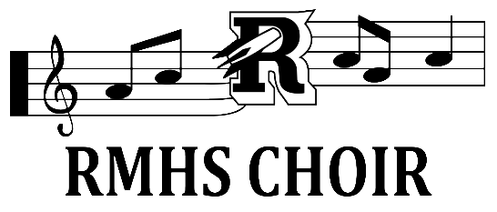

Harmonium Callbacks

Lauren Cook - SI
Kylie Encarnacao - SI
Eva Bonsey - SII
Tessa Goldlust - SII
Grace Brown - SII or Alto
Tallulah Patalano - Alto
Finn Frank – Alto or Tenor
Will O’Connor - Tenor
Liam Synnott - Tenor
Dionysios Georgopoulos - Bass
Miles Sopchak – Vocal Percussion

An email with more information about callbacks has been sent to students and parents!

